Running head: STUDYING THE IMPACT OF INSTRUCTIONAL COACHING

Studying the Impact of Instructional Coaching
Jim Knight
University of Kansas
Kansas Coaching Project at the Center for Research on Learning
and
Jake Cornett
University of Kansas
Kansas Coaching Project at the Center for Research on Learning
and Department of Special Education
Studying the Impact of Instructional Coaching
Interest in the form of professional learning loosely described as coaching has grown dramatically in the past ten years. School districts and states are hiring thousands of coaches (e.g., there are currently more than 2,100 full-time coaches in Florida alone). However, little rigorous research has been conducted studying the effectiveness of this approach to professional development. As Michael Kamil (2006, p. 16) has succinctly commented, “At this point, we have absolutely no single piece of evidence that coaching is effective: no published research, no randomized control-style studies.” Given the keen interest in coaching, and the limited rigorous study of this approach to professional learning, further study of coaching is certainly needed. This study is designed to deepen our understanding of the potential impact of one particular approach to coaching: instructional coaching.
Instructional coaches are onsite professional developers who work collaboratively with teachers, empowering them to incorporate research-based instructional methods into their classrooms (Knight, 2007). This study was conducted to further our understanding of coaching by evaluating whether or not instructional coaches have (a) any impact on whether or not teachers implement proven practices that they learn in a professional development workshop and (b) any impact on the quality of teacher implementation of new teaching practices.
Coaching as Support to Teachers
The authors of this study reviewed more than 250 publications describing research on coaching (Cornett & Knight, 2008). Based primarily on practitioner experiences this extensive literature review provided many recommendations for best practices for a variety of coaching approaches, but offered little empirical evidence from rigorous studies to support their recommendations (Cornett & Knight, 2008). Three approaches to coaching have some empirical evidence suggesting they are effective: (a) peer coaching (Bush, 1984; Manace-Ireland, 2003; Showers, 1982, 1983, 1984), (b) cognitive coaching (Hull, Edwards, Rogers, & Sword, 1998), and (c) instructional coaching (Knight, 2004, 2005, 2006, 2007).
Instructional Coaching
In this experimental study the effects of instructional coaching are explored, and the effectiveness of instructional coaching at increasing the quality of instruction is tested. Instructional coaching is an approach to professional learning that involves practices (the components of coaching) and a theoretical framework (see, Knight, 2007). The components of coaching and the theoretical framework are described below in some detail.
Components of Coaching
Instructional coaches employ the following seven practices. First, the coach enrolls the teacher by conducting a one-to-one interview with each teacher prior to his or her experience of professional learning. The purpose of enrolling a teacher is to build rapport, learn about the collaborating teacher’s particular interests and concerns so that professional development could be differentiated, and explain how the new teaching practice to be learned might address teacher’s concerns. Second, the coach engages in collaborative planning with the teacher; the coach meets with the collaborating teacher to discuss how a new teaching practice can be implemented effectively. Then, working collaboratively the coach and teacher co-constructed an observation form to guide teacher observations of the coach, and coach observations of the teacher. Third, the coach models the lesson. The coach models a lesson in the collaborating teacher’s classroom while the teacher observes the lesson while using the co-constructed observation form that was developed during the previous practice. Fourth, the collaborating teacher and coach meet for the purpose of teacher-directed post conferencing. The coach and teacher meet to discuss what the teacher observed the coach doing while modeling the lesson. Fifth, the coach observes the lesson being taught by the teacher. The coach observes the teacher while teaching a lesson using the new teaching practice. While observing, the coach uses the same co-constructed observation form that the collaborating teacher used while observing the coach model the lesson. Sixth, the coach and teacher collaboratively explore the data. The coach and teacher discuss the data gathered during the mutual observations, discussing what each observed. Lastly, the coach provides continued support while the teacher implements. The coach continues to provide support until the teacher is fluent and habitual in their use of the new teaching practice.
These seven components create the practice used by an instructional coach when they are collaborating with teachers. The theoretical framework described next ties the seven components of coaching together. This theoretical framework is also referred to as the partnership approach to professional learning (Knight, 2007).
Theoretical Framework
The coaching practices employed by instructional coaches are grounded in seven principles: equality, choice, voice, dialogue, reflection, praxis, and reciprocity. Each of the seven principles is described subsequently. These seven principles provide a conceptual language for how instructional coaches interact with other professionals in the school.
Equality: Instructional Coaches and Teachers Are Equal Partners.
Partnership involves relationships between equals. Thus, instructional coaches recognize collaborating teachers as equal partners, and they truly believe that each teacher’s thoughts and beliefs are valuable. Instructional coaches listen to teachers with the intent to learn, to really understand, and then respond, rather than with the intent to persuade.
Choice: Teachers Should Have Choice Regarding What and How They Learn.
In a partnership, one individual does not make decisions for another. Because partners are equal, they make their own individual choices and make decisions collaboratively (Block, 1993). For instructional coaches this means that teacher choice is implicit in every communication of content and, to the greatest extent possible, the process used to learn the content. Instructional coaches do not envision making teachers “think like them” as the purpose of their job. Rather, an instructional coach’s goal is to meet teachers where they currently are in their practice and offer choices for learning.
Voice: Professional Learning Should Empower and Respect the Voices of Teachers.
All individuals in a partnership have opportunities to express their point of view. Indeed, a primary benefit of a partnership is that each individual has access to many perspectives rather than the one perspective of a leader (Covey, 2004; Lawrence-Lightfoot, 2000). Instructional coaches who act on this principle encourage teachers to express their opinions about content being learned. Instructional coaches view coaching as a process that helps teachers find their voice, not a process determined to make teachers think a certain way.
Dialogue: Professional Learning Should Enable Authentic Dialogue.
To arrive at mutually acceptable decisions, partners engage in dialogue. In a partnership, one individual does not impose, dominate, or control. Partners engage in conversation, learning together as they explore ideas (Bohm, 2000). For instructional coaches, this means that they listen more than they tell. Instructional coaches avoid manipulation, engage participants in conversation about content, and think and learn with collaborating teachers.
Reflection: Reflection Is an Integral Part of Professional Learning.
If we are creating a learning partnership, if our partners are equal with us, if they are free to speak their own minds and free to make real, meaningful choices, it follows that one of the most important choices our collaborating partners will make is how to make sense of whatever we are proposing they learn. Partners don’t dictate to each other what to believe; they respect their partners’ professionalism and provide them with enough information, so that they can make their own decisions (Brubaker, Case, Reagan, 1994; Killion & Todnem, 1991; Palmer, 1998; Schön, 1987). Thus, instructional coaches encourage collaborating teachers to consider ideas before adopting them. Indeed, instructional coaches recognize that reflective thinkers, by definition, must be free to adopt or reject ideas, lest they simply are not thinkers at all.
Praxis: Teachers Should Apply Their Learning to Their Real-Life Practice as They Are Learning.
Partnership should enable individuals to have more meaningful experiences. In partnership relationships, meaning arises when people reflect on ideas and then put those actions into practice. A requirement for partnership is that each individual is free to reconstruct and use content the way he or she considers it most useful (Bernstein, 1983). For instructional coaches this means that in partnership with collaborating teachers they focus their attention on how to use ideas in the classroom as those ideas are being learned.
Reciprocity: Instructional Coaches Should Expect to Get as Much as They Give.
In a partnership, all partners benefit from the success, learning, or experience of others—everyone is rewarded by what each individual contributes (Freire, 1970; Senge, 1990; Vella, 1995). For that reason, one of an instructional coach’s goals should be to learn alongside collaborating teachers. Learning about each teacher’s strengths and weaknesses while implementing new teaching practices will enhance a coach’s ability to collaborate with all other teachers and the coach’s skill in using the new teaching practice.
This theoretical framework is more fully discussed elsewhere (see, Knight, 1998, 2007). This study tested instructional coaching as a means of professional development for teachers. Specifically, the purposes of this study were as follows:
(1) investigate the extent to which teachers’ use of new teaching practices could be encouraged through instructional coaching,
(2) determine effects on the quality of use of a new teaching routine when supported by instructional coaching, and
(3) find out if effects of instructional coaching persist following termination of instructional coaching supports.
To address these purposes, a mixed methods study was conducted in which a simple between-subjects experimental design was employed. After a delay interviews were conducted following termination of the experimental study.

METHOD

Participants
Fifty-one teachers were recruited to participated in this study. Teachers had to meet two criteria: 1) they could not have used the Unit Organizer or 2) attended a professional development session on the Unit Organizer in the past three years. All teachers volunteered to participate and were paid $150.00 after completion of the study. One teacher dropped out of the study before data collection began. In total, 50 teachers completed the study. All participants provided informed consent and were instructed of their rights prior to participation. Demographic characteristics of participating teachers are included in Table 1.

Setting
This study took place in classrooms in six middle and two high schools in an urban school district with an ethnically diverse student population of approximately 14,000 in the midwestern United States. Classrooms served students inclusively, meaning that students with and without disabilities were educated in the same classroom. The average percent of students eligible for free and reduced priced lunch across the eight secondary schools in this study was 68.2%, ranging from 53% to 87.8%.

Materials
The Unit Organizer
The Unit Organizer is one of several routines from the Content Enhancement Series developed at the University of Kansas Center for Research on Learning. The Content Enhancement Series of routines are designed to help faculty “teach large amounts of information to academically diverse classes in ‘learner friendly’ ways” (Lenz et al., 1994, p. 2). The Unit Organizer Routine (teaching routine) is used along with the Unit Organizer Device (device). Among other things, the device serves as a graphic organizer of content to be covered during the unit and relates that information to past and future units. See figure 1 for a sample of the device. All teachers received the teaching routine manual (Lenz et al., 1994). When delivered with professional development, the teaching routine manual is designed to provide all of the necessary information for a teacher to use the teaching routine and device proficiently. This study used this scientifically based teaching routine to study whether instructional coaching as an intervention increases rate and quality of teachers’ implementation of this new teaching practice.
Observation Instrument
An observation instrument was developed by the researchers to systematically determine whether teachers implemented the teaching routine and to measure the quality of teachers’ use of the new teaching routine. Each item was scored as observed or not observed. The first item listed on the observation instrument read, “Was there any evidence of use of the teaching routine or device?” This item served as the most general measure and was intended to capture whether or not teachers attempted use of the new teaching routine during the study or chose not to attempt use whatsoever.
To measure the quality of teacher implementation, four instructional behaviors that teachers should employ daily when teaching the routine effectively were included on the instrument: 1) beginning the lesson with a review of past content while referring to the device, 2) introducing the lesson using the device to orient students in relation to the larger unit, 3) adding new information to the device when appropriate, and 4) using the device to end each lesson with a review of the material covered while showing how this relates to the larger unit theme. These four items listed above were adapted from the teaching routine manual (Lenz, et al., 1994) to be directly observable behaviors. Scores for each of these four behaviors were summed such that a minimum score of zero and a maximum score of four were possible each day.
Procedures
A certified Strategic Instruction Model Content Enhancement Professional Developer led a professional development workshop designed to teach participants how to use the teaching routine during daily instruction (Lenz et al., 1994). This session occurred after school and lasted 1.5 hours. All 50 teachers who completed the study attended the workshop then completed a demographic questionnaire. Approximately 95% of teachers reported that the workshop was typical of, or better than, most workshops they have attended.
Following the workshop, participants were randomly assigned within each school to one of two conditions. In this experimental study, teachers were randomly selected to either: (a) receive instructional coach support following initial workshop for the duration of one unit, or (b) receive no support following the workshop. A ratio of one instructional coach to one school was used during this study. The intervention tested in this study was the instructional coaching model of professional development described previously in this manuscript (Knight, 2007).
Twenty-three trained research aides (RAs) observed one class period of each teacher daily for one unit of study (i.e., 1 to 8 weeks). RAs were blind to which condition each teacher was assigned to. In total, RAs collected data during 551 class periods and two RAs observed 40% percent of these periods simultaneously. Their independent scoring was used to determine an inter-rater reliability score, which was 98%.
Observation measures were taken for all participants and compared by the independent variable, professional development (instructional coaching or workshop only) to assess the extent to which participants used the teaching routine and the quality of daily use. After the teacher had been observed for one complete unit of study, observations stopped and teachers in the instructional coaching professional development condition no longer had access to an instructional coach to aid them in implementation of this teaching routine. A fidelity to intervention measures was used.
Intervention Fidelity
To ensure that instructional coaches in the eight secondary schools were following the instructional coaching model (Knight, 2007), all conversations between instructional coaches and teacher participants were audio recorded. A researcher who is a master coach (i.e., Coach-of-Coaches professional developer) listened to a sample of these audio recordings using a fidelity checklist containing key behaviors that should be present during coaching. Of the 43% of audio recordings that were checked for fidelity, all of the behaviors were observed in every recording indicating that the intervention was delivered with complete fidelity to the instructional coaching model.
Semistructured Interviews
To determine if gains persisted, participants were interviewed 8 to 12 weeks after termination of observations and instructional coaching. A second researcher and three-doctoral Fellows from the University of Kansas Center for Research on Learning interviewed a sample of 22 coached and 17 non-coached teachers using a semi-structured interview protocol. Interviews lasted 45 to 60 minutes. Teachers assigned to the instructional coaching professional development condition were asked seven additional questions beyond what teachers assigned to the workshop only condition were asked. The seven additional questions were designed to determine if coaching was delivered with fidelity and discover what elements of instructional coaching were helpful to the teacher while attempting to implement the teaching routine. These interviews were audio recorded then later coded by the second researcher. Interviews occurred approximately 2 to 3 months after teachers had finished teaching the unit in which the RAs observed them. The interviews served four primary purposes, to:
(1) determine whether teachers who were supported by instructional coaches continued to use the teaching routine after coaching had stopped more frequently than teachers who attended the workshop only;
(2) explore teacher perceptions of the utility of the teaching routine in aiding teacher instruction and student learning;
(3) examine the barriers to implementing the teaching routine; and
(4) triangulate observation data collected during the experimental study.

RESULTS
Experimental Study
A two-way contingency analysis was conducted to evaluate whether teachers were more likely to implement the new teaching routine when 1) supported by an instructional coach after attending an afterschool workshop or 2) only attending the after-school workshop. The two variables were professional development with two levels (instructional coach and workshop only) and observed behavior also with two levels (behavior not observed and behavior observed). Professional development and observed behavior were found to be significantly related, Pearson χ² (2, N = 547) = 184.57, p < .001, Cramér’s V = .581. The proportion of days the routine was used by the coaching support and workshop only participants were 91.5 and 36.2, respectively. Figure 2 shows the frequency count of days of observed behaviors for the two groups.
An independent-samples Welch’s t test was conducted to evaluate the hypothesis that teachers would use the teaching routine at a higher quality when supported by instructional coaching professional development as opposed to only attending the workshop. Welch’s t test was used due to observed unequal variance between the two professional development levels. Results were consistent with the research hypothesis, t(40.25) = 5.975, p < .0001. Teachers in the workshop only condition (M = 1.08, SD = 1.18) on the average used the teaching routine at a lower quality than those in the coaching support condition (M = 2.81, SD = .81).
Participants self-selected whether or not to use the teaching routine as a part of their daily lesson plan. Because the quality of use measure is dependent upon the routine having been used, a second independent-samples t test was conducted using a subset of the daily mean scores. The subset was selected by removing quality scores from the mean and standard deviation of the two independent variable groups when there was no evidence of use of the teaching routine. This second t test was used to evaluate the sub-hypothesis that when teachers self-selected to use the teaching routine, teachers would use the routine at a higher quality when supported by instructional coaching professional development over teachers who only attended the workshop. Again, this test was significant, t(39) = 2.981, p = .005, with the results consistent with the research hypothesis. Among teachers who selected to use the new teaching routine as part of the daily lesson plan, teachers in the workshop only condition (M = 2.48, SD = .65) on the average used the teaching routine at a lower quality than those in the coaching support condition (M = 3.09, SD = .62). The 95% confidence interval for the difference in means was wide, ranging from .20 to 1.02. The eta square index indicated that 19% of the variance of the quality use variable was accounted for by whether a teacher was assigned to coaching support or workshop only condition. Figure 3 shows the distribution for the two groups.
Using the measures of teacher quality in this study, an effect size was calculated using data from days when use of the new teaching practice was attempted. The effect size of instructional coaching on teacher quality implementation of new teaching practices was large, d = .96 (Cohen, 1988).
Semi-Structured Interviews
Twenty-two of the teachers who were assigned to the coaching professional development condition and 17 of the teachers who were assigned to the workshop only professional development condition participated in semi-structured interviews. Interviews occurred 8 to 12 weeks after instructional coaching had suspended and RA observations had terminated. This delay was used to determine if teachers in both conditions of professional development sustained use of the new teaching routine over time at an equal frequency after the coaching professional development support was removed. Teachers who were supported by instructional coaching reported that they continued to use the new teaching practices during the delay more frequently (15 of 22) than did teachers who attended the workshop only (3 of 17). When asked if the teaching routine was of value to the instructor, teachers supported by instructional coaching and workshop only professional development answered mostly in the affirmative. The frequencies were 20 of 22 and 14 of 17, respectively.
Further, all of the teachers supported by coaching stated the teaching routine was helpful for their students’ learning of the content they taught. Whereas approximately half of the teachers who only attended the workshop stated the same when questioned (12 of 22). In examining the responses of those 12 teachers who only attended the workshop and reported the routine was helpful for student learning, only half of those teachers reported that they planned to use the routine in the future (6 of 12). This result was surprising. Given that they reported the routine was helpful for student learning, one would expect continued use of the teaching routine. Overwhelmingly, the most frequent barrier to implementation referenced during the interviews was the lengthy amount of planning time required to develop a device and plan the entire unit prior to instruction beginning. Five of the teachers who were supported by coaching and seven of the teachers who only attended the workshop reported this barrier.

DISCUSSION
Teachers who were supported by an instructional coach used the teaching routine more than teachers who only attended a professional development workshop. Also, teachers who were supported by an instructional coach demonstrated the four teaching practices of high quality implementation more frequently than teachers who were not supported by an instructional coach. Although the results would suggest that instructional coaching is a promising approach to increasing quality transfer of training into classroom practice, there are several limitations that demand future study before such a claim can be definitively justified.
Limitations and Directions for Future Research
First, all the teachers who attended the initial workshop chose to attend because they were interested in the unit organizer, in the monetary incentive, or for some other reason. A direction for future research would be a replication of this study when professional development attendance is compulsory, which occurs frequently in school districts. Second, the study of student achievement in coached classrooms in comparison to non-coached classrooms was beyond the scope of this study. However, research in this area would extend the body of knowledge on coaching as a form of professional development and subsequent student learning. Conversely, if research-validated practices are implemented with fidelity, we might assume that student achievement would improve which would relegate the need for costly, experimental research. Nevertheless, further study of this would be useful in determining the effects of instructional coaching on student achievement.
Third, this study established instructional coaching as an effective means of professional development for teachers in urban secondary schools. However, it is unknown whether particular components of the instructional coaching model are more effective than others. For example, are all seven components of coaching equally necessary and powerful? To answer this question, further study of the components of coaching is needed. Fourth, results from this study do not bear light on whether the adopted theoretical framework presented in this study is necessary for successful implementation of a coaching program. Further study is needed to suggest whether or not an alternative theoretical framework (for example, a more “top-down” model focused on uniform fidelity of implementation) would be more or less effective than the partnership framework employed by instructional coaches in this study.
Conclusions
In this experimental study, results clearly indicated that teachers who were coached were more likely than teachers who only attended a workshop to use a new teaching practice inside the classroom during the study and after RAs stopped observing. Also, teachers who were coached reported they were more likely to use the new teaching practices in the future. In summary, this study suggests that instructional coaching will increase the likelihood that teachers adopt new teaching practices. The results also suggest that instructional coaching will increase the likelihood that teachers will use the practices with a higher degree of quality inside the classroom when compared with teachers who do not receive coaching support following professional development.
As was the case in this study, we suggest pairing instructional coaching with teaching practices that are research based and have a strong track record of improving academic outcomes for student. Namely, teaching practices and routines that have the potential to increase high-stakes state exam scores, improve course grades, or increase inclusion of students with disabilities. On the one hand, this study adds to the body of literature (Bush, 1984; Showers, 1982, 1984) showing that most teachers will not use new teaching practices inside the classroom if the only learning opportunity available to them is a one-time in-service professional development workshop. On the other hand, the results of this study suggest that teachers will implement proven practices with a high degree of quality if skilled instructional coaches support teachers following the one-time workshop.
Please note that we do not suggest that professional development workshops should not be used in secondary schools. Rather, workshops serve the important function of introducing new ideas, practices, and innovations into a school. However, to be maximally effective workshops should be followed by additional support for teachers. When teachers are expected to change their instruction, additional support is necessary. The results from this study suggest that instructional coaching is one additional support that will increase the transfer of new teacher knowledge into practice.

REFERENCES
Bernstein, R. J. (1983). Beyond objectivism and relativism: Science, hermeneutics, and praxis. Philadelphia: University of Pennsylvania Press.
Block, P. (1993). Stewardship: Choosing service over self-interest. San Francisco: Berrett-Koehler.
Bohm, D. (2000). On dialogue. New York: Routledge.
Brubaker, J. W., Case, C. W., & Reagan, J. G. (1994). Becoming a reflective educator: How to build a culture of inquiry in the schools. Thousand Oaks, CA: Corwin.
Bush, R. N. (1984). Effective staff development. In making our schools more effective: Proceedings of three state conferences. San Francisco: Far West Laboratories.
Cohen, J. (1988). Statistical power analysis for the behavioral sciences (2nd ed.). Hillsdale, NJ: Lawrence Earlbaum Associates.
Cornett, J., & Knight, J. (2008). Research on Coaching. In J. Knight (Ed.) Coaching: Approaches and perspectives. Thousand Oaks, CA: Corwin.
Covey, S. (2004). The eighth habit: From effectiveness to greatness. New York: Simon & Schuster.
Freire, P. (1970). Pedagogy of the oppressed. New York: Continuum.
Hull, J., Edwards, J. L., Rogers, M. S., & Swords, M. E. (1998). The Pleasant View experience. Golden, CO: Jefferson County Schools.
Kamil, M. (2006). What we know-and don’t know-about Coaching? A conversation with professor Michael Kamil. Northwest Education, 12, 16-17.
Killion, J. P., & Todnem, G. R. (1991). A process of personal theory building. Educational Leadership, 48, 14-16.
Knight, J. (1998). The effectiveness of partnership learning: A dialogical methodology for staff development. Lawrence, KS: University of Kansas Center for Research on Learning.
Knight, J. (2004). Instructional coaches make progress through partnership: Intensive support can improve teaching. Journal of Staff Development, 25, 32–37.
Knight, J. (2005). A primer on instructional coaching. Principal Leadership, 5, 17-20.
Knight, J. (2006). Instructional coaching: Eight factors for realizing better classroom teaching through support, feedback and intensive, individualized professional learning. The School Administrator, 63, 36-40.
Knight, J. (2007). Instructional coaching: A partnership approach to improving instruction. Thousand Oaks, CA: Corwin.
Lawrence-Lightfoot, S. (2000). Respect: An exploration. New York: HarperCollins.
Lenz, B. K., Bulgren, J. A., Deshler, D. D., & Schumaker, J. B. (1994). The Unit Organizer Routine. Lawrence, KS: Edge Enterprises.
Maniace-Ireland, D. A. (2003). Job-embedded professional development: Teachers as adult learners. Dissertation Abstracts International 64(8), 2722. (UMI No. 3103215)
Palmer, P. (1998). The courage to teach: Exploring the inner landscape of a teacher’s life. San Francisco: Jossey-Bass.
Schön, D. A. (1987). Educating the reflective practitioner. San Francisco: Jossey-Bass.
Senge, P. M. (1990). The fifth discipline: The art and practice of the learning organization. London: Random House.
Showers, B. (1982). Transfer of training: The contribution of coaching. Eugene, OR: Centre for Educational Policy and Management.
Showers, B. (1983, April). Transfer of training. Paper presented at the annual meeting of the American Education Research Association, Montreal, Canada.
Showers, B. (1984). Peer coaching: A strategy for facilitating transfer of training. Eugene, OR: Centre for Educational Policy and Management.
Vella, J. (1995). Training through dialogue: Promoting effective learning and change with adults. San Francisco: Jossey-Bass.

Table 1
Participant Demographic Information by Treatment Condition
______________________________________________________________________________
Demographic Treatment Condition
Category Coached (n = 26) Non-Coached (n = 24)
Age 39.15(11.3) 35.96(10.2)
Race/Ethnicity
White 65.4% 91.7%
Black/African American 15.4% 4.2%
Latino/Hispanic 3.8% 0%
Asian 15.4% 0%
American Indian/Alaskan Native 0% 4.2%
Gender
Male 19.2% 29.2%
Female 80.8% 70.8%
Years as Educational Professional 8.67(7.5) 7.13(5.9)
Highest Degree Earned
Conditional License^{α} 0% 4.2%
Bachelors 76.9% 66.7%
Masters 23.1% 29.2%
^{α}Conditional Licenses are issued on a provisional basis while coursework that is associated with completion of a teaching degree and licensure is finished.

Figure 1. Sample device covering a unit on the causes of the civil war. There is also an expanded unit map, usually found on the reverse of the paper (omitted here for space).

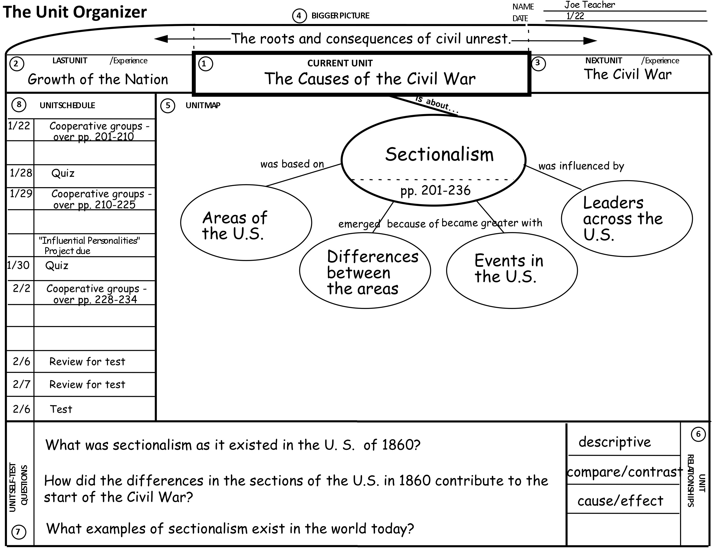
Figure 2. This clustered bar chart shows frequency of observations within professional development categories.

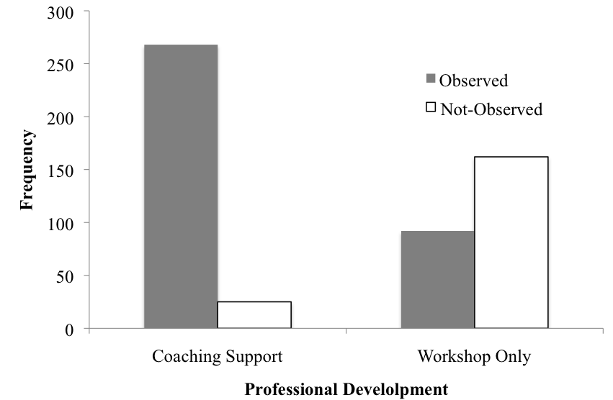
Figure 3. Mean score for quality of use and error bars indicating 2 standard deviations above and below the mean. Data represented are from days when the routine was attempted.

